* 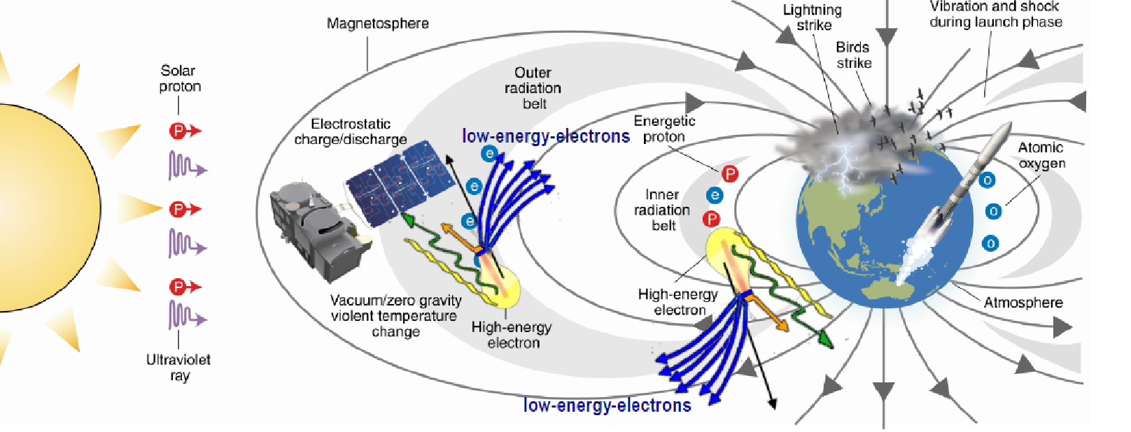
* **LEE 2022**
* **Tuesday, November 15th, 2022 –**

**CNR Area della Ricerca di Roma 1, SP35d, 9, 00010 Montelibretti (RM)**

**Sala Convegni**

**PARTICIPATION FORM**

Please fill out this form and send by email to the following address:

[stefano.iacobucci@ism.cnr.it](mailto:anna.pitzus@mec-partners.it)

with object : LEE 2022 participation Name Surname.

Name_____________________________Surname _____________________________________

Institution: _____________________________________________________________________

Work address:   
Street ________________________________Town ___________________CAP _____________

email ________________________________

Telephone __________________________ Cellular___________________

**􀀀 I plan to attend in person 􀀀 I plan to participate by ZOOM**

**􀀀 I plan to lunch at the canteen of the Area**

􀀀 I consent to the processing of my personal data according to current legislation

Date_______________________Signature_____________________________________________